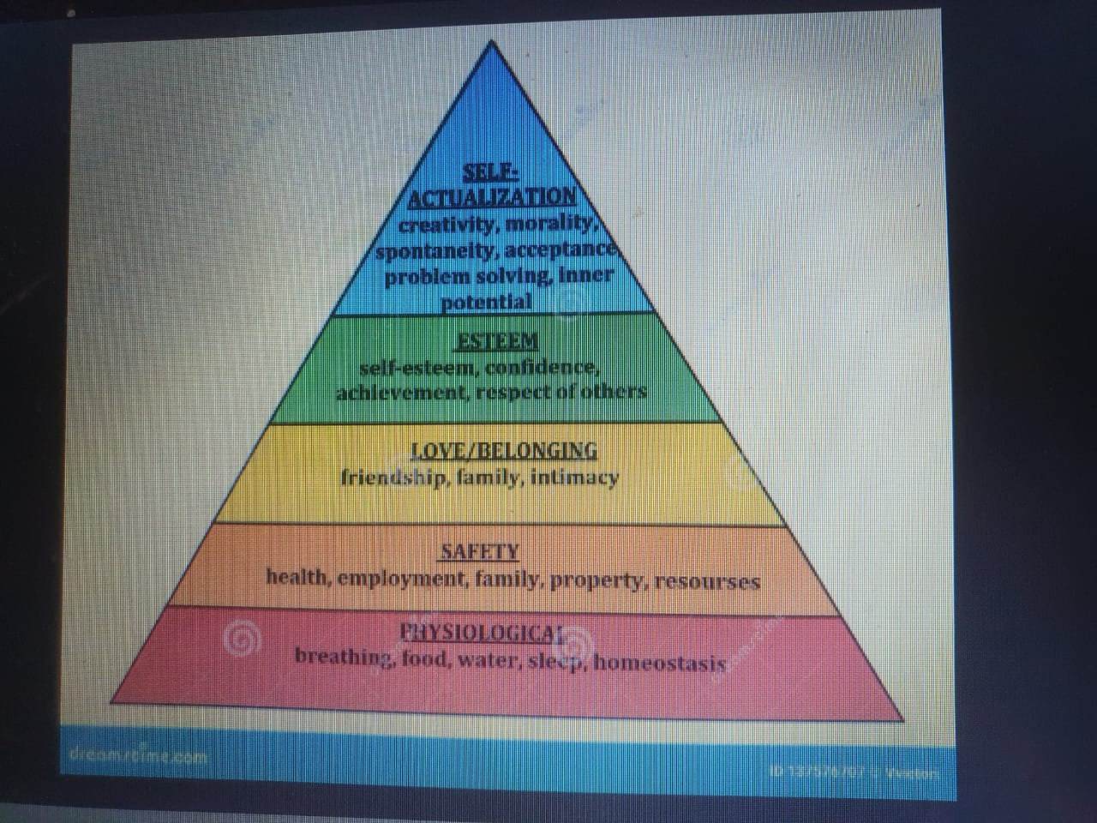
This is Maslow’s Hierarchy of Needs. It shows what motivates people in life. First, we need our basic needs like food and safety. Then, we look for love, confidence, and finally, we try to become the best version of ourselves. The idea is, we can only focus on higher goals when our lower needs are fulfilled.

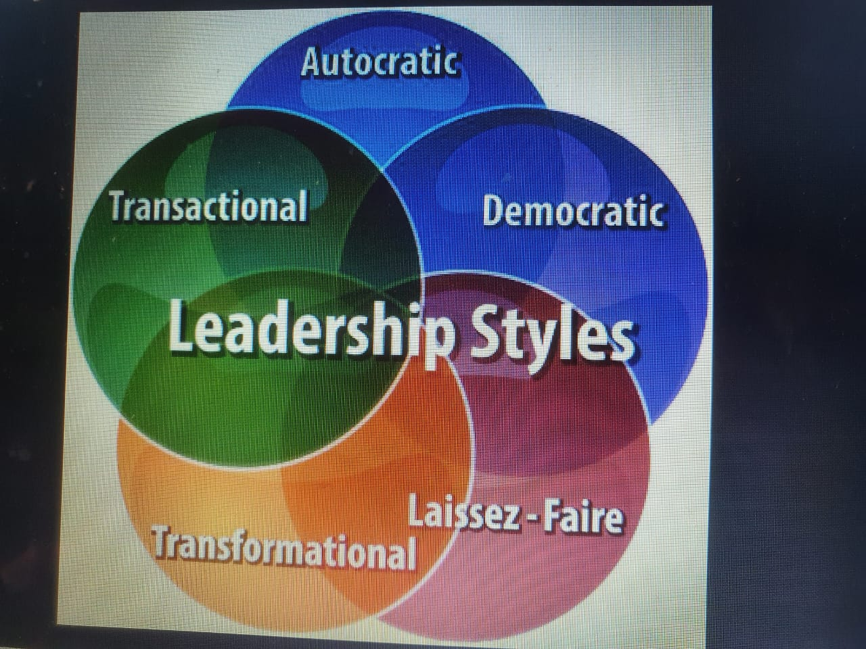
This image shows different leadership styles. Each one is a way leaders guide others. Some are strict like autocratic, some are teamwork-based like democratic, and some inspire change like transformational. The best style depends on the situation and the people involved.

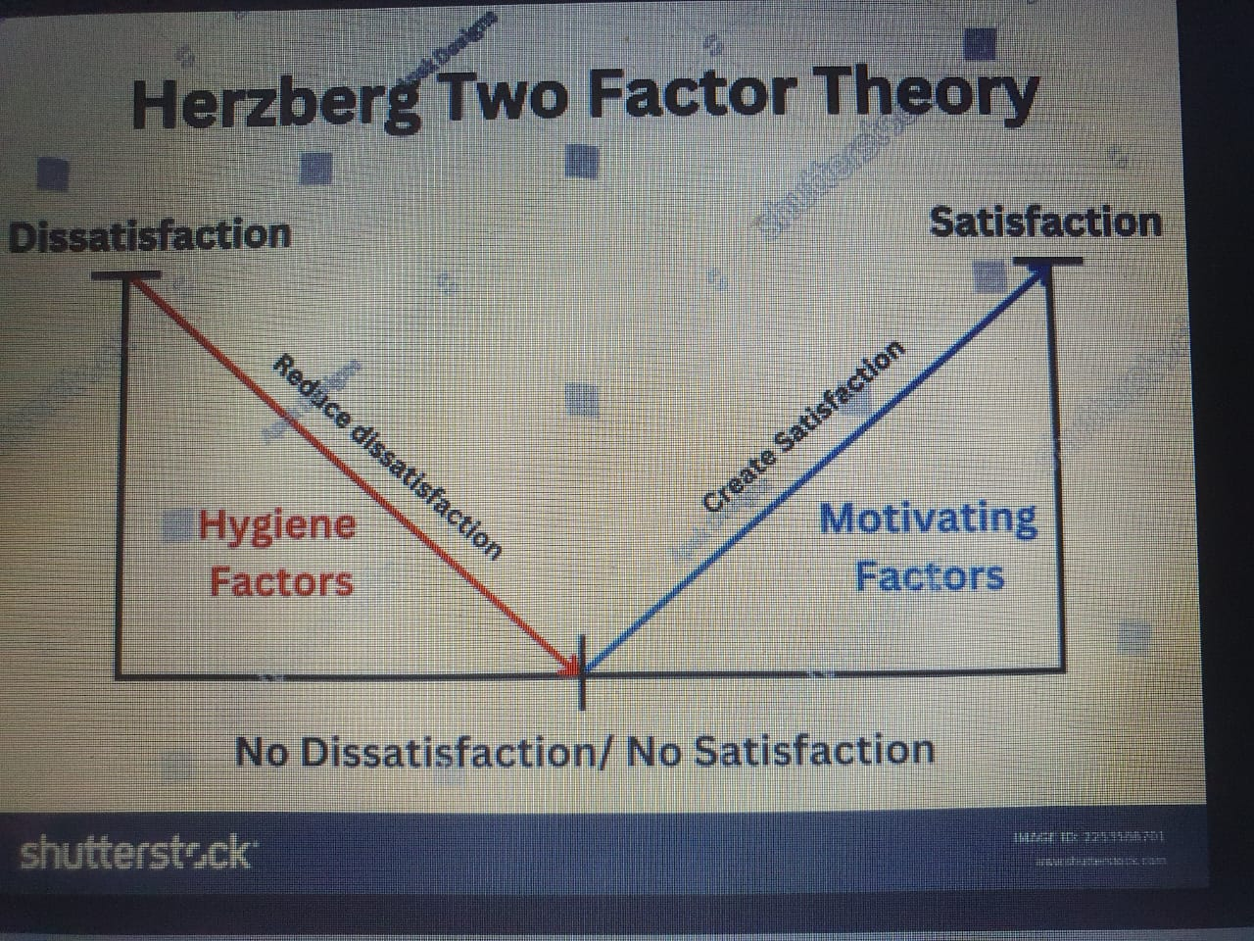
Herzberg's Two-Factor Theory explains what makes employees unhappy and what truly motivates them. Hygiene factors, like salary or safe working conditions, stop people from being dissatisfied but don’t motivate them. Motivating factors, like recognition or personal growth, actually make people feel satisfied and driven. Both are important but work in different ways.

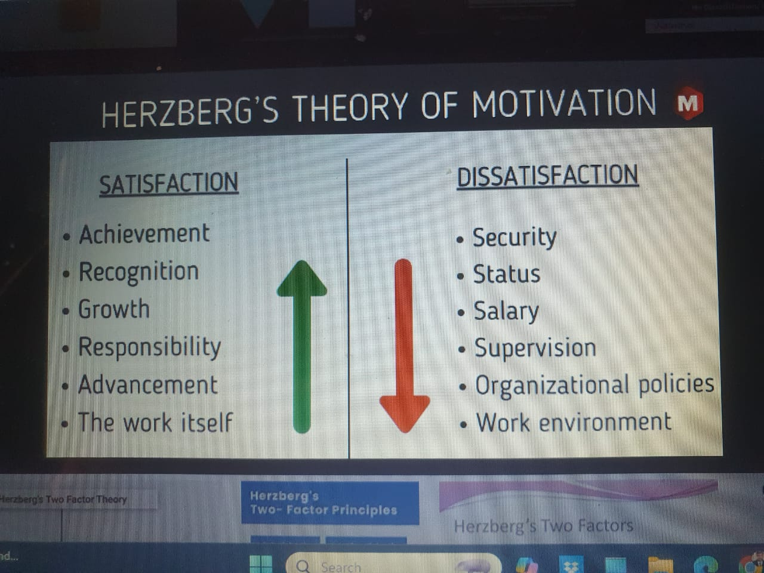
To keep employees motivated, improve both motivators and hygiene factors.
2. Hygiene Factors (Prevent Dissatisfaction):
These don’t motivate much, but their absence causes dissatisfaction:
- Security
- Status
- Salary
- Supervision
- Company policies
- Work environment
❌ Poor hygiene factors cause dissatisfaction, even if motivators exist.

1. Motivators (Lead to Satisfaction):
These make employees happy and motivated:
- Achievement
- Recognition
- Growth
- Responsibility
- Advancement
- The work itself
✅ Presence increases satisfaction and motivation.

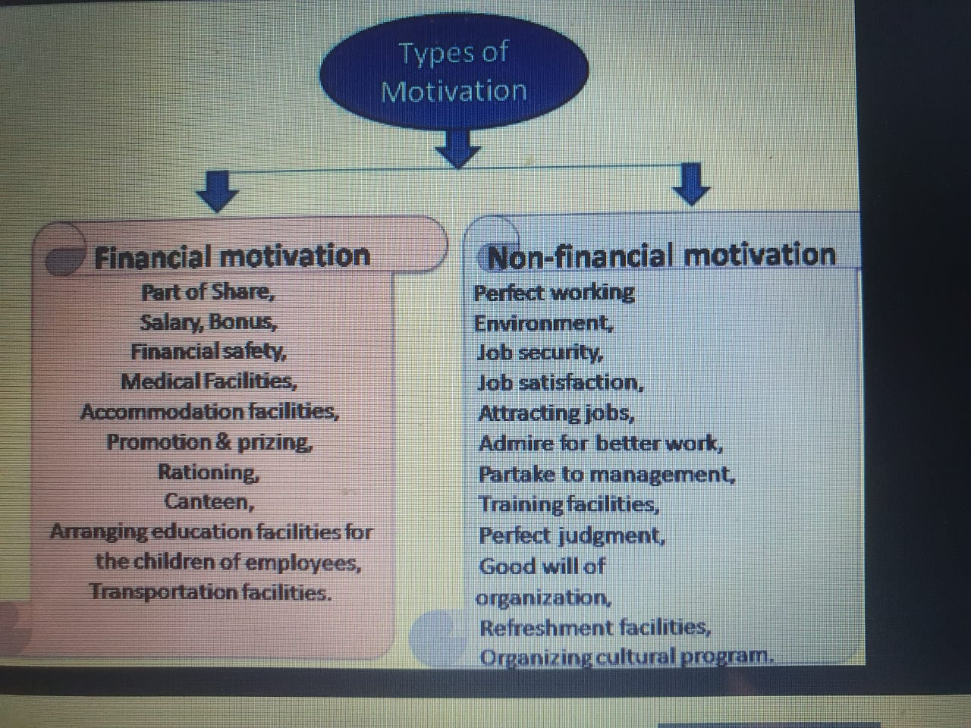
Financial motivation gives material rewards, while non-financial motivation improves job satisfaction and work culture.
2. Non-financial Motivation:
Motivation without giving money, focusing on emotional and workplace satisfaction:
- Good working environment
- Job security & satisfaction
- Recognition and admiration
- Employee involvement in decisions
- Training & development
- Fair treatment
- Organizational goodwill
- Cultural and refreshment programs
🤝 These improve employee morale and loyalty.

1. Financial Motivation:
Motivation through money or material benefits:
- Salary, Bonus
- Shares, Financial safety
- Medical & Accommodation facilities
- Promotion & Prizes
- Rationing, Canteen
- Education for employees' children
- Transport facilities
💰 These are direct benefits in terms of money or services.

